C219 Front-end Web Development

**Lesson 1**

Worksheet

Understanding the Problem

1. What is the main reason Little Toy Kingdom wants to set up an online store?
2. What information would they need before creating an online store?

The Web Design Process

1. What are the steps involved in a web design process / workflow? Fill in the table below with the web design process stages and their description.

|  |  |
| --- | --- |
| **Web Design Process** | **Description** |
| Requirement Analysis | This is the first step in the web design process and is crucial because what is decided and mapped here sets the stage for the entire project. This is also the part that requires lots of client interaction and planning |
| Design | This is typically involves moving the information outlined in the planning stage further into reality. The main deliverables are a documented site structure and, more importantly, a visual representation |
| Development | Development involves the bulk of the programming work, as well as loading content. Keep code organized and refer constantly to the planning details as the full website takes shape. This is where you implement your frameworks, content management systems and libraries, and test all features |
| Launch | The purpose of the launch phase is to prepare the website for public viewing. This requires final polishing of design elements, deep testing of interactivity and features and, most of all, a consideration of the user experience. An important early step in this phase is to move the website, if need be, to its permanent web server. Testing in the production environment is important because different servers can have different features and unexpected behaviour. |
| Maintenance | Business re-enters the picture at this point as you take care of all the little tasks related to closing the project. Packaging source files, providing instructions for use and any required training occurs at this time. |

The Principles of Design

1. Recall the principles of design you have learnt from T252 Fundamentals of Design. List them below and describe what they mean.

|  |  |
| --- | --- |
| **Principles of Design** | **Description** |
| Contrast | Contrast involves the juxtaposition of different elements within a design to create visual interest and make certain elements stand out. This can include contrasting colours, shapes, textures, or sizes. The greater the contrast, the more attention a particular element will receive. |
| Emphasis | Emphasis refers to the focal point or center of interest within a design. It is the element or area that is intended to capture the viewer's attention and convey the primary message. Emphasis is achieved using contrast, scale, colour, and other design techniques. |
| Balance | Balance is the distribution of visual elements within a composition to create a sense of stability and harmony. It involves the arrangement of elements, such as shapes, colours, and objects, so that the visual weight is evenly distributed across the design. |
| Scale and proportion | Scale and proportion involve the relative size and dimensions of elements within a design. These principles help create a sense of perspective, depth, and relationship between different elements. Proper scale and proportion are essential for realistic and visually pleasing designs. |
| Rhythm | Rhythm is the repetition or alternation of visual elements to create a sense of movement, pattern, and flow. It is akin to the rhythm in music, where certain elements are repeated at regular intervals. |
| Unity | Unity the integration of all design elements into a coherent and visually pleasing whole. It ensures that the elements in the design work together to convey a consistent message or concept. |

1. Can these principles be applied to web design? Explain.

The Principles of Web Design

1. Conduct your own research and derive some principles of web design. Fill in the table below with the principles of web design together with an explanation.

|  |  |
| --- | --- |
| **Principles of Web Design** | **Description** |
| Easy Navigation | Keep the navigation bar simple with clear options.  Follow real-world conventions or use the user’s language for naming the menu items.  Avoid too many clicks to a web page. |
| Consistency in Design | Have a fixed colour theme.  Use a specific set of fonts.  Use familiar patterns.  All other visual styles should be consistent in style. |
| Digestible Content | Use white space.  Ensure overall design is clean.  Apply visual hierarchy.  Be specific and concise. |
| Optimum Performance | Compress files.  Optimise images.  Avoid using too many images, videos, animations.  Use website testing tools. |

Parts of a Web Page

1. What are the various parts of a web page? List them in the table below and describe them. Include a screenshot of a web page and label the parts.

|  |  |
| --- | --- |
| **Parts of a Web Page** | **Description** |
| Header | The top part of a website containing the logo and usually the site’s navigation menu. |
| Navigation | Links at the top of the page to help you find what you’re looking for. |
| Banner | A large image you see at the top of a web page that grabs your attention. |
| Content | All the elements used to communicate your message - text, images, video, audio, etc. |
| Footer | Performs the same function as the header except a footer is at the bottom of a page instead of the top. Contains contact info, privacy policy, terms of use, sitemap, social media icons and links to other important pages on your site. |

Website Analysis

1. Study [Shopee.sg](https://shopee.sg/). What is the main objective of this website?

Shopee serves as a platform for various sellers to list their products for sale. Users can browse and purchase a diverse range of items, including electronics, fashion, beauty products, home goods, and more.

1. Is this website a good example for Little Toy Kingdom to emulate? Why?

No. Little Toy Kingdom specializes in children's toys, which is a niche market. While Shopee's broad approach works for a wide range of products, a specialized store should focus on the specific needs and preferences of its target audience.

1. List a few effective websites for Little Toy Kingdom to refer to for inspiration. Provide reasons for your choices. You can list as many websites as you like.

|  |  |
| --- | --- |
| **Websites** | **Reasons** |
| LEGO (www.lego.com) | LEGO is a great source of inspiration for a toy store. It features a clean and colourful design that appeals to children. The website is well-organized, with product categorization and an easy-to-navigate layout. LEGO also incorporates interactive elements, games, and engaging content. |
| Toys"R"Us (www.toysrus.com) | While Toys"R"Us has gone through changes in recent years, their historical website and its previous designs can offer insights into how a large toy retailer organized their product listings, provided useful search functionality, and employed colourful, kid-friendly designs. |

** Exercise 1 – Web Page Creation (Individual Work)**

1. Apply your prior knowledge in HTML and CSS to create a two-page website with the following key requirements:
   1. Page 1 – About Me
      * A heading
      * An image of yourself
      * A section containing information about you
   2. Page 2 – My Fav Food
      * A heading
      * An image of your favourite food
      * A short description about the food

Both pages should link to one another. You are not allowed to use any framework or template. You may add any other content that will enhance your web pages. Refer to [https://www.w3schools.com](https://www.w3schools.com/) for HTML and CSS tutorials.

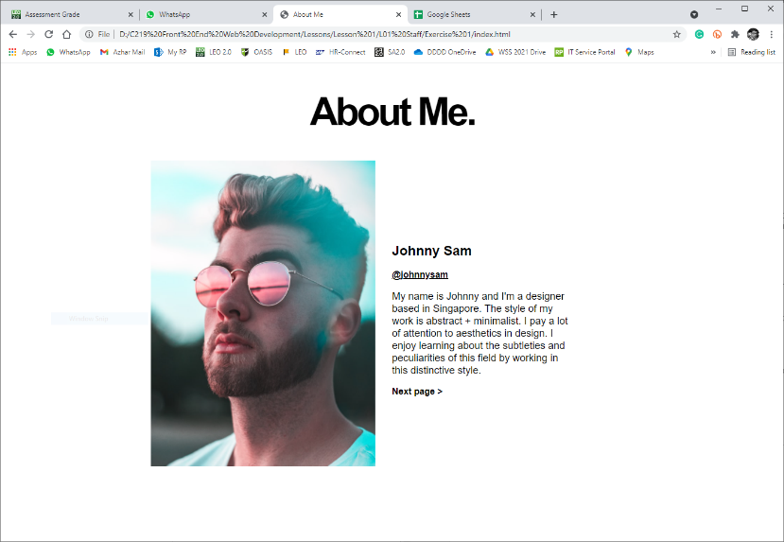

Page 1 Example

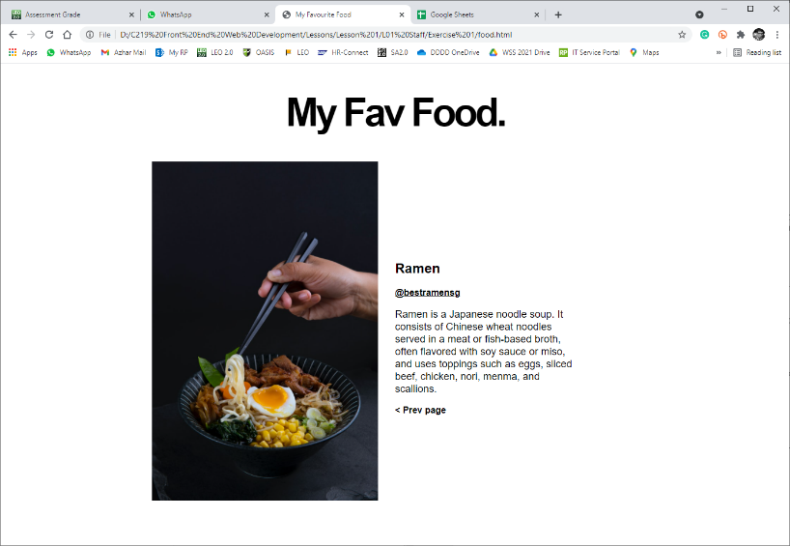

Page 2 Example

 **Solving the Problem (Teamwork)**

1. Create a website containing the information below:
   1. The principles of web design
   2. The parts of a web page
   3. A complete plan for the development of Little Toy Kingdom’s online store. You are to include details on the various stages in the web design process together with a project schedule / timeline.

1) Home Page (Aqeel)

2) About Us (Diya)

3) Products (Sze Yan)

4) Delivery (Ian)

5) Login (Jocelyn)

6) Cart (Hazim)

Colour scheme #87CEEB blue (background )

#FF69B4 pink

#0000FF blue (link)

Delivery image: https://www.advotics.com/en/delivery-order/

* 1. Two website examples for Little Toy Kingdom’s reference. Provide screenshots and reasons for your choices.

reference : <https://tfortoys.com>

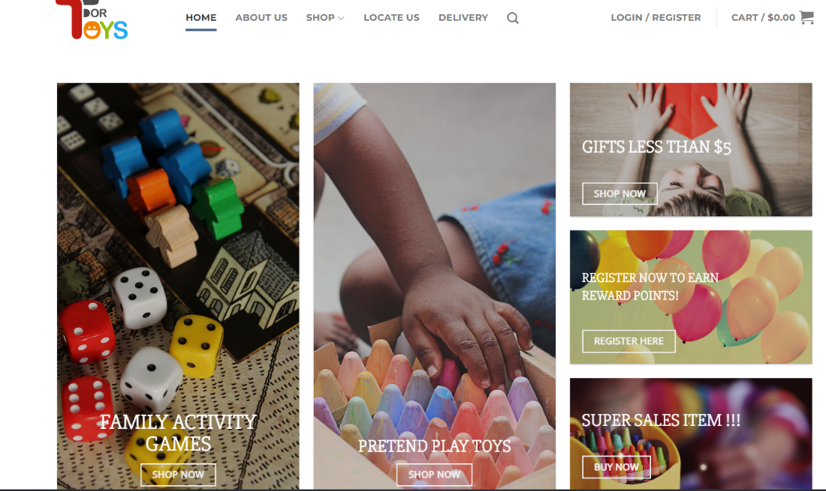

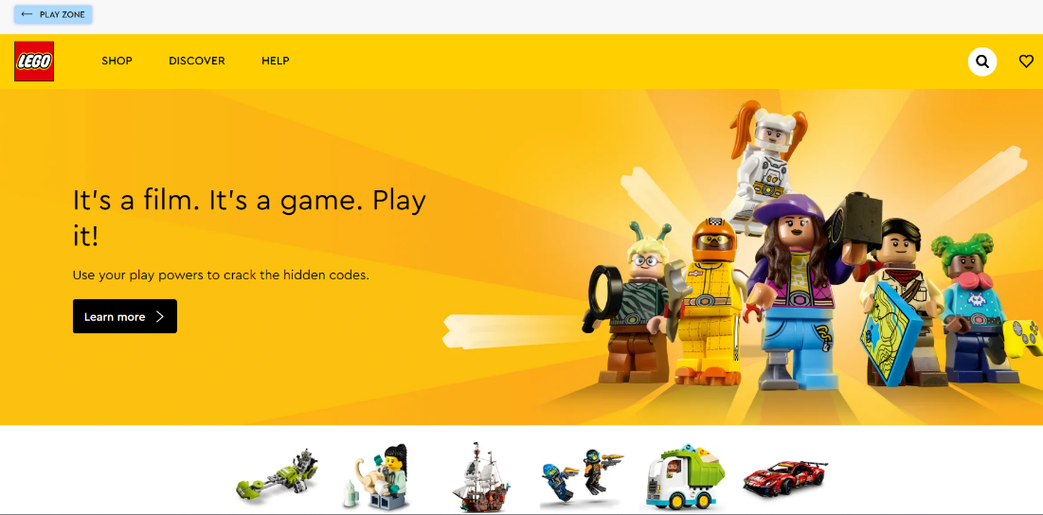

You may add more pages where necessary. You are not allowed to use any framework or template.

 **Deliverables**

Individual submission:

* Exercise 1

Team submission*:

* Worksheet
* Website^

* To be submitted by team leader only

^ Indicate your name on the web page(s) that you did

**Submit all deliverables by 3pm today.**